H.T No
Regulations:
A18

Sreenidhi Institute of Science and Technology
(An Autonomous Institution)
Code No: 7A304 Date: 12-Sept-2024 (FN)

B.Tech II-Year I- Semester External Examination, Sept - 2024 (Supplementary)
ELECTRICAL CIRCUITS AND NETWORKS – II (EEE)

Time: 3 Hours Max.Marks:70

Note: a) No additional answer sheets will be provided.
b) All sub-parts of a question must be answered at one place only, otherwise it will not be valued.
c) Missing data can be assumed suitably.

Bloom's Cognitive Levels of Learning (BCLL)

Remember | L1 | Apply | L3 | Evaluate | L5
Understand | L2 | Analyze | L4 | Create | L6

Part - A Max.Marks:20
Answer all QUESTIONS

 |  | BCLL | CO(s) | Marks
1 | Define symmetrical system and phase sequence. | L1 | CO1 | [2M]
2 | What is the behavior of capacitance at t=0 and t=∞. | L2 | CO2 | [2M]
3 | Define poles and zeros in a transfer function. | L1 | CO3 | [2M]
4 | Classify different types of two port network parameters? | L3 | CO4 | [2M]
5 | Write short notes on band pass filters? | L1 | CO5 | [2M]
6 | Write the formulae for Fourier constants for f ( x) in the interval (-Π, Π). | L1 | CO6 | [2M]
7 | What is meant by balanced three phase supply? | L1 | CO1 | [2M]
8 | Define DC gain of a system function? | L1 | CO3 | [2M]
9 | What are desirable characteristics of ideal filter? | L1 | CO5 | [2M]
10 | Explain condition of symmetry for z-parameters? | L6 | CO6 | [2M]
Part – B Max.Marks:50
ANSWER ANY FIVE QUESTIONS. EACH QUESTION CARRIES 10 MARKS.

 |  |  | BCLL | CO(s) | Marks
11. | a) | Derive the relationship between a line current and phase current related to a delta connected load. | L5 | CO1 | [5M]
 | b) | Two wattmeters in a 3-phase, 3-wire system with an effective line voltage of 120V read 1500W and 500W. What is the impedance of each arm of the balanced delta connected load? What is the power factor of the load? | L3 | CO1 | [5M]
12. | a) | Derive the expression for transient response of series R-C circuit driven by sinusoidal excitation by using Laplace transform method. | L5 | CO2 | [5M]
 | b) | A series RC circuit has a constant voltage of E, applied at time t = 0 as shown in Fig. below. The capacitor has no initial charge. Find the equations for i, V_{R} and V_{C}. Sketch the wave shapes. E = 100 V R = 5000Ω C = 20 μF  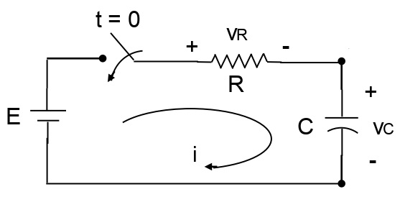 | L3 | CO2 | [5M]
13. | a) | Write the necessary conditions for driving point function. | L2 | CO3 | [5M]
 | b) | For the network shown in figure determine the transform impedance Z(s).  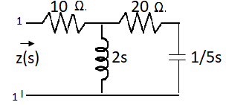 | L1 | CO3 | [5M]
14. | a) | Obtain the z parameters for the network in Fig.  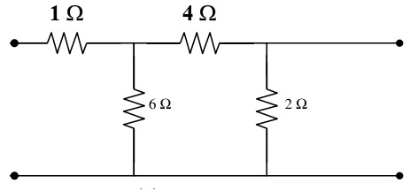 | L3 | CO4 | [5M]
 | b) | Discuss the condition of Reciprocity in h-Parameter representation. | L2 | CO4 | [5M]
15. | a) | What is a high pass filter? In what respects it is different from a low pass filter? Explain. | L1 | CO5 | [5M]
 | b) | Derive the equation to find the inductances and capacitances of a constant-K high pass filter. | L2 | CO5 | [5M]
16. | a) | Write note on i) Half wave symmetry ii) Quarter wave symmetry | L1 | CO6 | [5M]
 | b) | What are the fourier coefficients? Derive the expressions for the fourier coefficients of the fourier series. | L5 | CO6 | [5M]
17. | a) | What are the advantages of a three phase system? | L2 | CO1 | [4M]
 | b) | Find the current in a series R-L circuit having R=2Ω and L=10H while a DC. voltage of 100V is applied. What is the value of this current after 5 sec. of switching on? | L1 | CO2 | [3M]
 | c) | Draw the pole zero diagram for the given network function I(s) and hence obtain i(t).  I(s) = | L3 | CO3 | [3M]
18. | a) | Express ABCD parameters in terms of h parameters. | L5 | CO4 | [4M]
 | b) | A prototype high pass filter has a cut off frequency of 8 KHz and nominal impedance of 600 ohms. Calculate the values of inductance and capacitance used in the filter. | L3 | CO5 | [3M]
 | c) | Find the fourier transform of the time function 3e^{-t} cos4t u(t) | L3 | CO6 | [3M]

-- 00 -- 00 –

